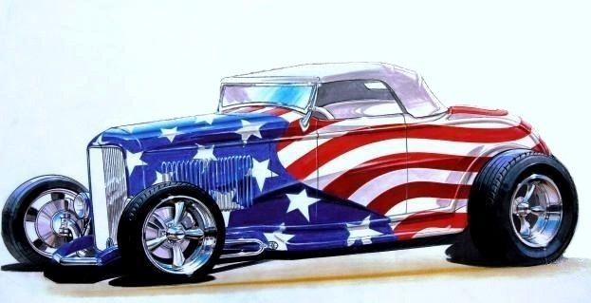
The 18th Annual

Prince William Cruisers
’

In Conjunction With

Occoquan Regional Park
9751 Ox Road-Lorton, VA
All Proceeds go to Virginia Veterans Services Foundation Sunday, September 13th, 2026 From 9:00 AM to 3:00 PM (Rain date: Sep 27th) All Vehicles Welcome (Cars, Trucks & Motorcycles)
Registration (9 to 12) Fee: $20.00 per vehicle
HOOD MUST BE OPENED TO BE JUDGED
Dash Plaques to the First 125 Registrants — Top 50 Awards
Special Awards: Best Paint, Best Engine, Best Rat Rod, Best Late Model, Best Motorcycle, Occoquan Park Pick, Best of Show, Joseph “Oobie” Duley Memorial Award
50/50 — T-SHIRTS — REFRESHMENTS BY LUNCHBOX ON WHEELS — DJ Lyle For More Info: Call Steve @ (703) 971-8455 — www.PrinceWilliamCruisers.com Alcohol, Illegal Substances, Loud Music or Reckless Behavior Will Not Be Tolerated!!!

